**MURANG’A LAW COURTS**

**CASE FILE MANAGEMENT SYSTEM**

**DEVELOPED BY MAKOKHA FREDRICK AND DAVID WANDATI**

**APPROVED BY THE JUDGE AND THE CHIEF MAGISTRATE**

**MAIN OBJECTIVE: TO HELP IN MANAGING FILES AND RESPONDING TO CLIENT ENQUIRIES ABOUT THEIR CASES**

**PRESENTED TO THE LMT ON 23/03/2017**

**PRESENTED TO THE STAFF ON 24/03/2017**

**USER GUIDE**

**2017**

Table of Contents

ABSTRACT 3

CONFIGURATION 3

DATABASE SETUP 5

SYSTEM CONFIGURATION 9

DISTRIBUTING THE SYSTEM 11

BACKUP STRATEGY 13

# **ABSTRACT**

The system is a web-based application developed with php as the back-end language and html and JavaScript as the front-end languages. This requires that the system runs on a central server machine from where it can be accessed by other computers as long as they know the IP address of the server machine. This manual gives a step-by-step guide to the configuration and execution of the system. Xampp will be used to run the system with its Apache server acting as the application server and Myql acting as the database server-DBMS.

# **CONFIGURATION**

For convenience, the Apache and Mysql servers should be made to run as a service so that they run every time the server computer is on, eliminating the need to start Xampp every time the computer is powered on. Below are the steps to be followed in making these start as services.

First, install Xampp on your computer and if possible direct the installation to a drive other than C in windows so that OS crashing may not lead to loss of data.

Secondly, start Xampp as admin then select the two services to be starting automatically; as shown in the screen screenshots below; (To locate the xampp control panel after installation, press the Windows button the start typing x…a..m..p..p to search and the panel will appear on top. Then right-click on it and “run as administrator  
"

When the control panel has appeared, click on ‘Config’ then check Apache and MySQL in the ‘Autostart of modules’ panel as as shown below. Be sure to also check the box for starting the control panel minimized. After that, click save.

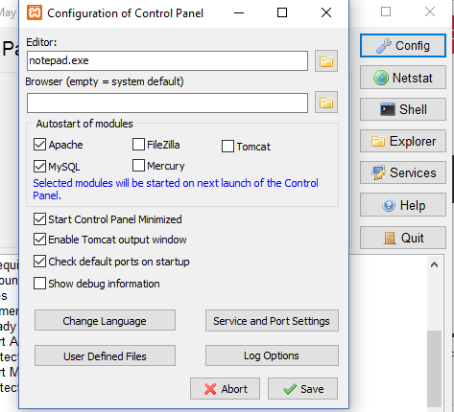

The next step is to go to the folder where Xampp is installed, if it was installed in drive D the go to D then open Xampp folder and check for a file called ‘xampp-control.exe’, right-cick on it and go to ‘create shortcut’, as shown below

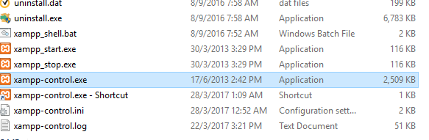

You’ll notice the shortcut is created just below then main file, copy this shortcut file and paste it in C:\Users\**User-Name**\AppData\Roaming\Microsoft\Windows\Start Menu\Programs\Startup folder. You may have to enable viewing of hidden files to see the *AppData* folder. That’s it. Restart…

# **DATABASE SETUP**

Having configured the xampp control panel to be starting on start up and running Apache and MySQL as services, now it’s time to configure the database. This step should be done after restarting the compared after the above step. To do this, go to your browser and on the address bar and type ‘localhost/phpmyadmin/’ then hit enter. The below page appears (Only if the xampp started and MySQL is running). A page similar to the one in the figure below appears. Click on ‘New’ and the on the ‘Create database’ panel enter exactly ‘mlc’ as the name of the database and click ‘Create’. Do not touch the ‘Collation’ part.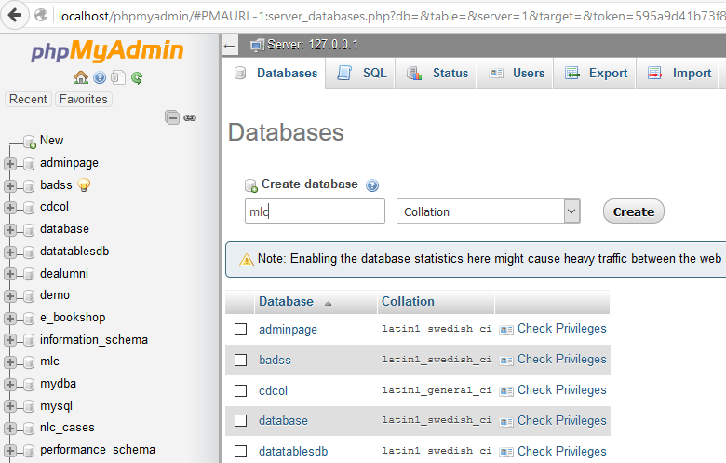

The newly created db appears in the list of dbs, click on it

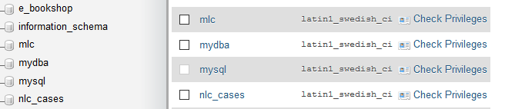

Then click ‘import’ tab on top of the page so that the following page appears

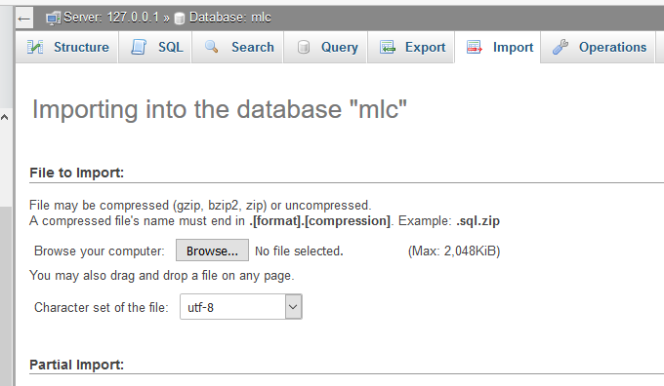

Click browse and select the mlc.sql file; it is placed within the project folder. Locate it and select it.

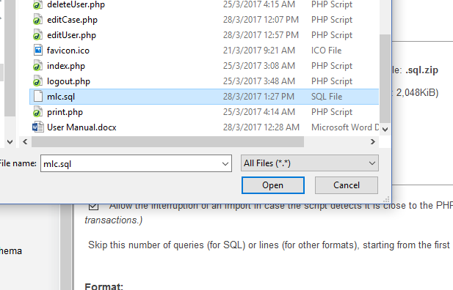

Then click the ‘Go’ button found at the bottom left corner of the page.

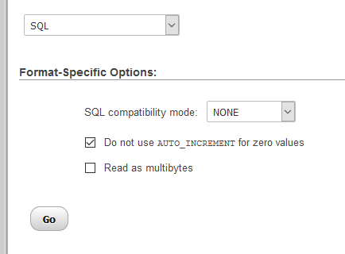

That’s it, we have our tables now

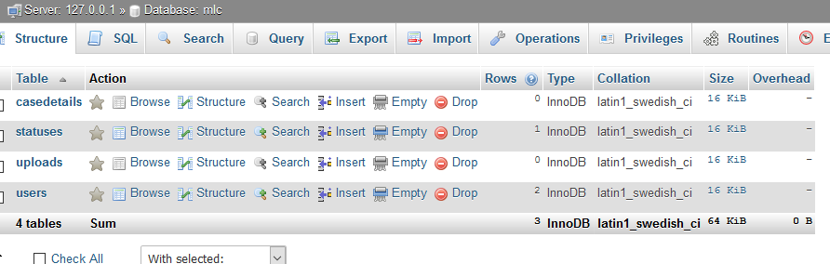

Let’s set up the main admin who will then add the others. click on the table ‘users’ then delete any existing information by clicking the delete button.

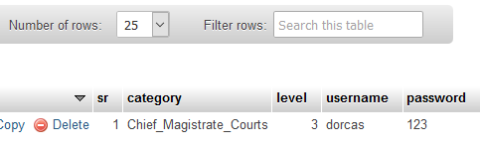

Then click insert on the top tabs and enter the following information. Be sure to enter the **EXACT** word ‘Admin’ in the category section and 1 in the level field but you can set any value for username and password. Leave the ‘sr’ field empty as shown.

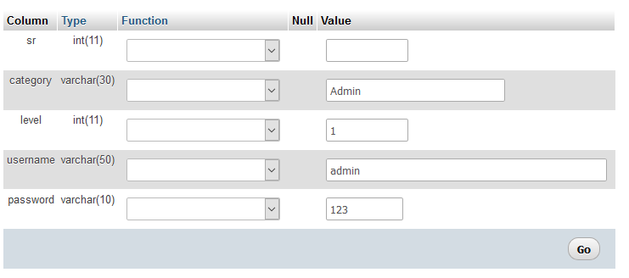

Click ‘Go’. The below window appears, click browse

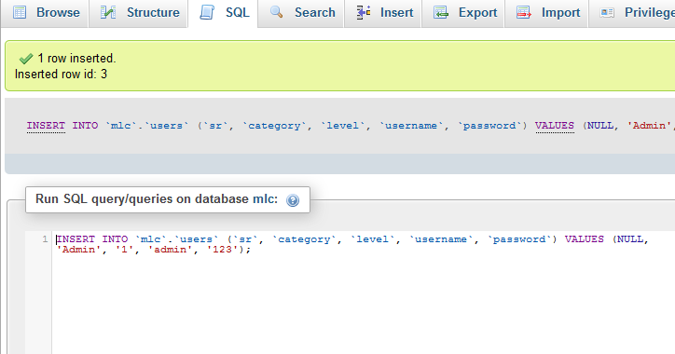

Keep the username and password in mind, we’ll use it again and again.

# **SYSTEM CONFIGURATION**

With the database in place, what remains is to set the system in place. For it to be accessed via the browser, the project folder has to be placed in the htdocs folder of xampp. Therefore, copy the project folder labelled ‘mlc’ then go to where you installed xampp, open the xampp folder, locate the htdocs folder and paste the project folder there.

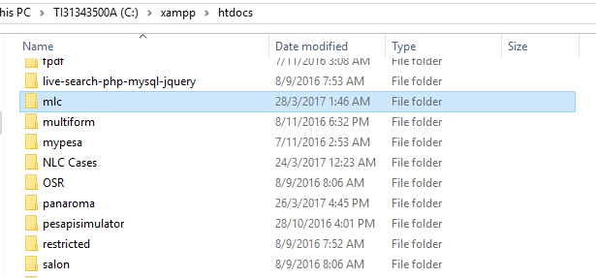

That’s all about the setting up the system. Next we want to access the system on the browser and add users. Go to your browser and type on the address bar ‘localhost/mlc/’ then hit enter. By now you can close the tab with the ‘phpmyadmin’ page. The below page appears.

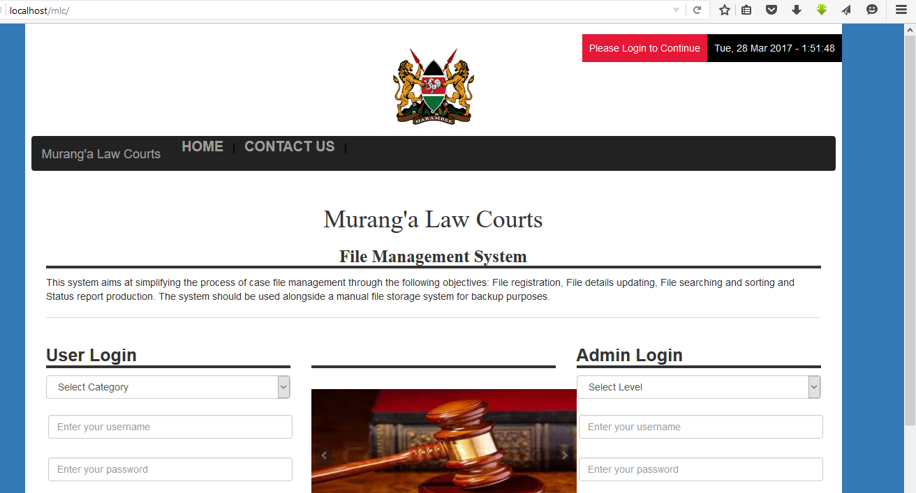

Go to the Admin Login and select ‘Admin’ level then enter the username and password we set up and click ‘Login’ or hit enter.

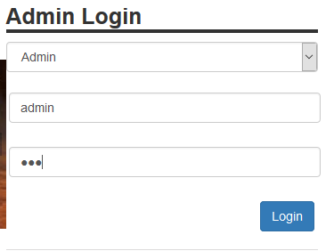

Then appears the admin page and being the overall admin, you are able to sign up other admins and also yourself. You can also edit and delete records. Set up the admins of the other courts and give them the usernames and passwords.

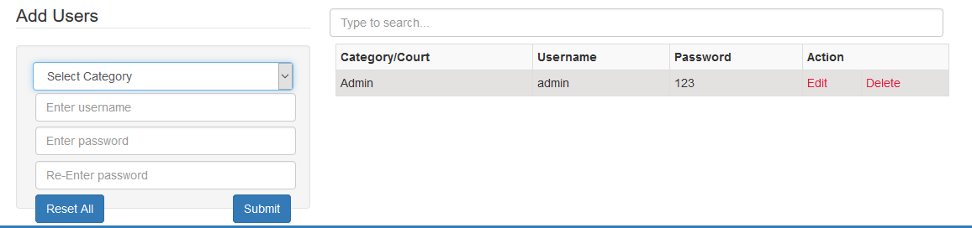

Note:

As the main admin, you’ll be able to add other admin users but not court users. The admin users will only add users in their courts. You will not be able delete files but you are the only one who will be able to view deleted files. They’ll be marked as ‘File deleted’ in their statuses.

# **DISTRIBUTING THE SYSTEM**

This is a distributed system in nature and is able to be accessed by other users on other computers as long as both computers are connected via the same LAN (whether or not there’s internet connection) and if the host IP address is known. So make sure both computers are connected via the same LAN and the check the IP address of the server machine, probably by running the ‘ipconfig’ command in CMD and recording the IPV4 address.

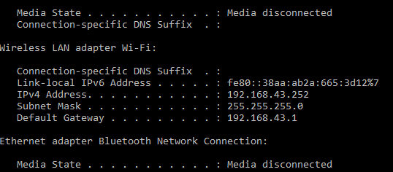

192.168.43.52 is the address in this case. Go with this address to other computer, open its browser and on the address bar type this address followed by the name of the project as shown: 192.168.43.52/mlc/ then hit enter.

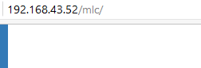

The same page can then be seen. You can supply this address to all users and tell them to be using it every time they want to access the system but that would be tedious to them. You can also the pages on their browsers and create desktop shortcuts so that they can access the site by double clicking the shortcuts on their desktops. To create shortcuts on Mozilla Firefox you go to the page that you wish to create the shortcut for and then minimize the page to the side such that you can see both the browser and the desktop. Then you drag the icon the on the left of the address bar to the desktop. Bingo! Shortcut created (<https://support.mozilla.org/t5/Learn-the-Basics-get-started/Create-a-desktop-shortcut-to-a-website/ta-p/1361>).

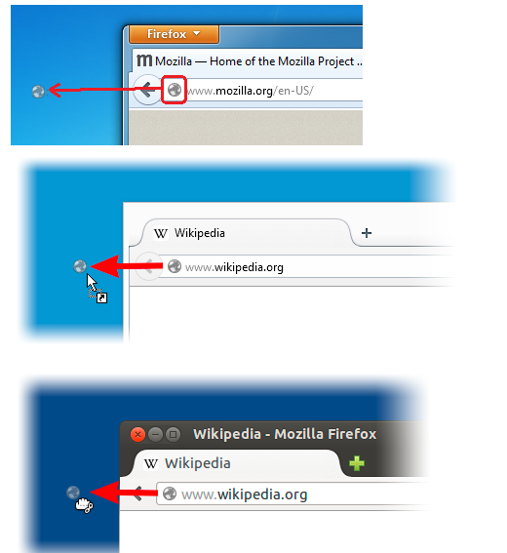

For Google Chrome, you click the settings icon on the right, the icon is either three vertical dots or a wrench, depending on the version. Then you click on it and go to more tools then you go to ‘create application shortcuts’ or ‘Add to desktop…’ again depending on the version. Then you click on it finish up promptly (http://www.laptopmag.com/articles/how-to-create-desktop-shortcuts-for-web-pages-using-chrome).

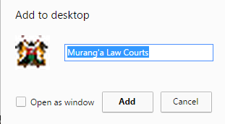

The use of icons will make the site appear desktop and will be more convenient for the users in terms of accessing.



Ask the admins to log in and add their users then present these users with their usernames and passwords. Make sure the server computer is always running. Remind the users that they can click the attachment icon to see attachments for cases that have them and delete those they want.

# **BACKUP STRATEGY**

I am still working on an automatic way to back up the data stored in the local database but for now you have to do it manually. You’ll be going to the server computer and typing ‘localhost/phpmyadmin/’ on the browser then on the page you click the ‘mlc’ database then click ‘export’ and save the file in a safe place. You’ll have to be doing every evening till a better solution is found. In case of a crash, the files you’ll be collecting will be used for recovery-The latest file to be precise.

Record every concern raised by users to be worked on and the system updated. Thank you.